Внеклассное мероприятие на английском языке «Удивительное вокруг нас»
Разработано: Каюровой О.В. и Дубровской Е.С. - учителями английского языка, МОУ СШ № 36 г. Ярославля.
Цели:
- формирование и поддержка мотивации обучающихся к изучению иностранных языков;
- приобщение к новому опыту использования английского языка посредством участия в мини-спектакле;
- предоставление возможности для обучающихся осознать значение иностранного языка как средства общения, познания и творческого самовыражения.
Задачи:
- научить обучающихся действовать, чувствовать и принимать решения;
- познакомить обучающихся с культурой стран изучаемого языка;
- развивать мотивацию к дальнейшему овладению иностранным языком;
- способствовать воспитанию личностных качеств (умение работать в команде, уважение к себе и другим, ответственность);
- дать возможность познакомиться с основами актёрского мастерства и научить свободно держаться на сцене, выступать перед коллективом.
Сценарий проведения мероприятия
Teacher: Dear friends! We have come here today to see and understand how wonderful the world around us is. There are so many countries, so many traditions and so many stories which interest and surprise us. Today we’ll have an experience of being Chinese actors, French Spider-men, British travelers, Mexican sculptors and the witnesses of historic events in York. Are you feeling thrilled?
Students: Yes!!!
Teacher: You are going to work in 5 teams. Here we have got a bag with colourful sheets of paper (blue, red, green, yellow and orange). Get one and you’ll know who you’ll be working with.
(Students are joining their teams.)
So, those who are ”red” will get acquainted and present the Chinese opera. Those who are “blue” will visit the haunted city of York. The “green” ones will show us the sculptures under the sea. The “yellow” team will be sharing their strange experiences. And the “orange” group will climb the tallest structures of the world together the French Spider-man.
Now listen! Each group has to go to a different classroom and prepare a short play according to the instructions you will be given. You will have 30 minutes to get ready.
(Students are going to the classrooms where they will have helpers with handouts. See instructions 1 – 5.)
And as now you have all come back, let us see what you have done.
(Students are showing their short plays.)
Teacher (after watching): You have done a great job and learnt a lot about wonders of the modern world.

Instruction 1
Planning Your Work
- Reading the text.
- Making costumes, scenery and decorations.
- Role distribution.
- Staging a mini-play.
- Rehearsal.
Instruction 2
Chinese Opera
1. Read the text.
2. Make 4 masks, a costume of an actor and a figure of Lady White Snake according to the pattern.
Result:
- 4 masks of different characters (a positive character, a warrior, a negative and a mystery character);
- one character in a kimono with ribbons and
- the figure of Lady White Snake.
Paints: red, black, blue, gold and silver; fiery reds, gold and silver; white.
3. 6 roles (characters).
4. Start your mini-play with “Welcome to the Chinese opera! We are going to show you … “(the characters describe themselves).
5. Rehearsal.

Instruction 3
The Haunted City of York
- Read the text.
- Colour the figures of
- a plumber;
- a soldier on a horse;
- Roman soldiers with shields and spears (other members of the team).
Paints: blue, black, red, white, yellow, brown.
- See the roles above (vide supra (v.s.) – Latin).
- Start your mini-play with the words of the Plumber: “You know the city of York has one haunted house where ghosts appear from time to time. One day I … “(not only the plumber is speaking, but the Roman soldiers should be speaking too).
- Rehearsal.
Instruction 4
Strange Experiences
- Read the text,
- Colour the figures and objects according to the pattern:
- a young man;
- his mother and
- father;
- 2 old ladies;
- a receptionist;
- a street (with old houses, old-fashioned people and not many cars);
- a double-decker.
Paints: of all colours (except silver and gold).
- 6 characters.
- Start your mini-play with the words of the Young man: “I have always wanted to visit London and one day …”
- Rehearsal.
Instruction 5
The French Spider-man
- Read the text.
- Colour the figures and objects according to the pattern:
- Alain Robert;
- tall buildings (the Eiffel Tower, the Empire State Building, the Petronas Twin Towers in Malaysia);
- spectator(s).
Paints: of all colours + the team members’ clothes are the costumes of the spectator(s) (don’t forget about the scarves).
- 5 characters (the buildings are speaking too).
- Start your mini-play with the words of the Spectator: “You will never believe that France has its own Spider-man! Not long ago my friends and I witnessed …”
- Rehearsal.
Instruction 6
Sculptures under the Sea
- Read the text.
- Colouring the figures and objects according to the pattern:
- the undersea world with corals;
- the sculptures of people;
- the sculptor himself;
- the divers with scubas.
Paints: of all colours (except black).
- 6 characters (objects are also speaking).
- Start your mini-play with the words of the Diver: “Have you ever heard about one of the wonders in Mexico? Have you ever seen people standing underwater among corals and not moving? Some time ago I dived …”
- Rehearsal.

Instruction for Helpers
Helpers are the students of the 10-11th forms.
They are to help distribute the roles and make speeches of characters for the mini-plays if the participants have problems.
They show photos in the form of examples to help with colouring the patterns.
Helpers bring paints, brushes, water, photos, patterns and scarves for the mini-plays.

Patterns for coloring. Opera
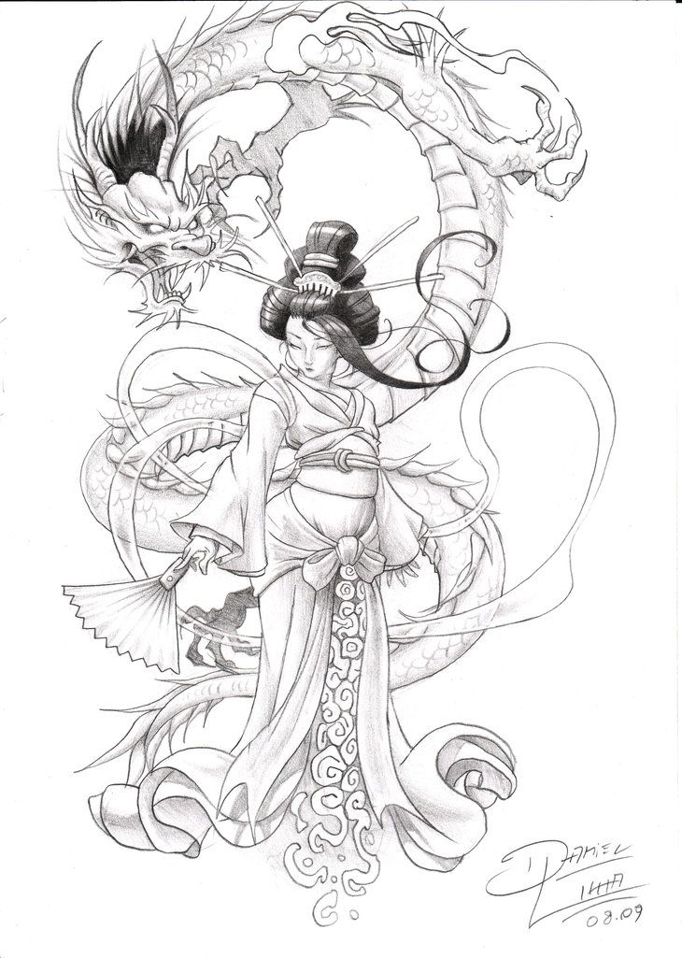

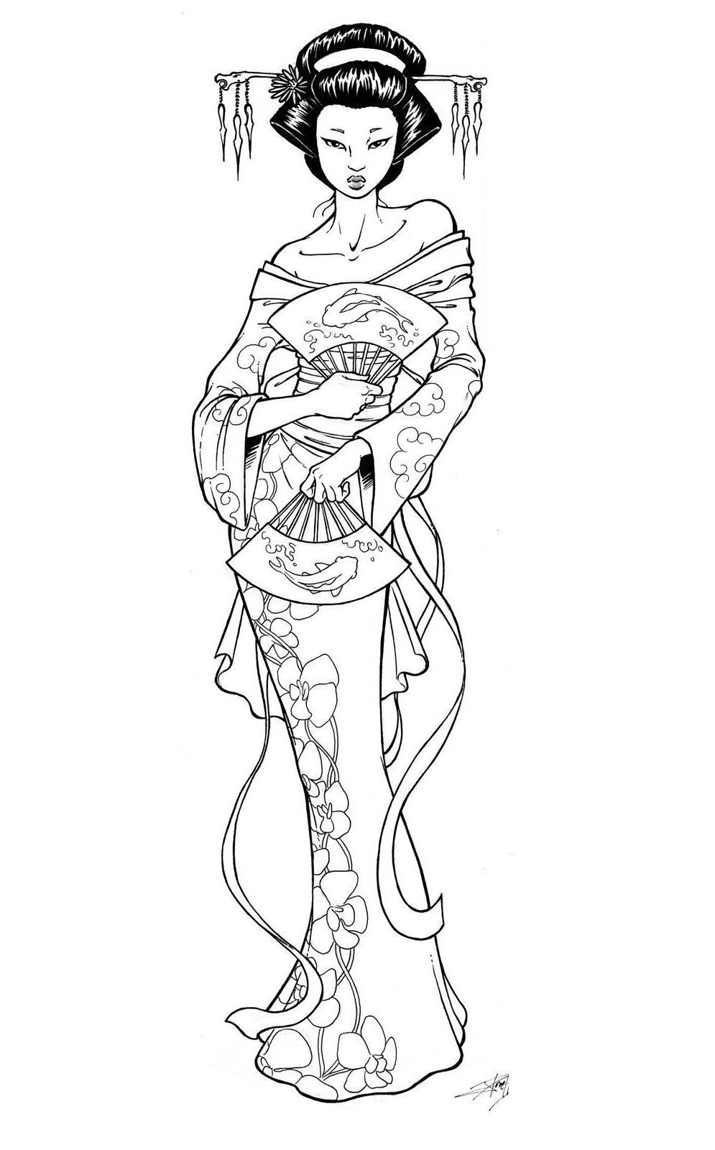
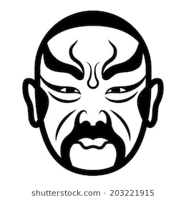

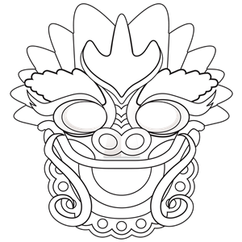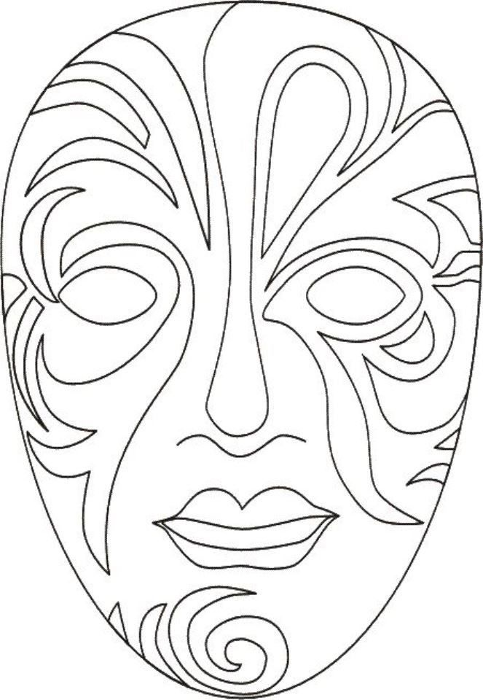
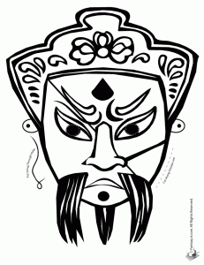

Patterns for coloring. Sculptures
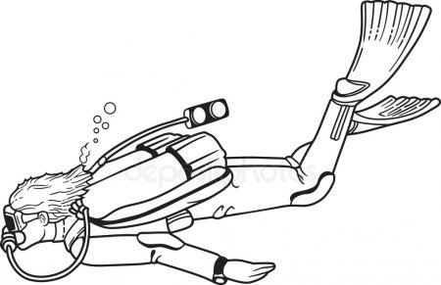

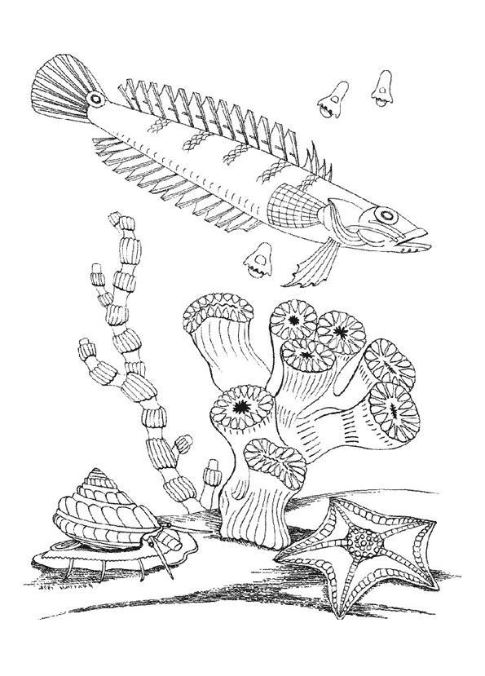
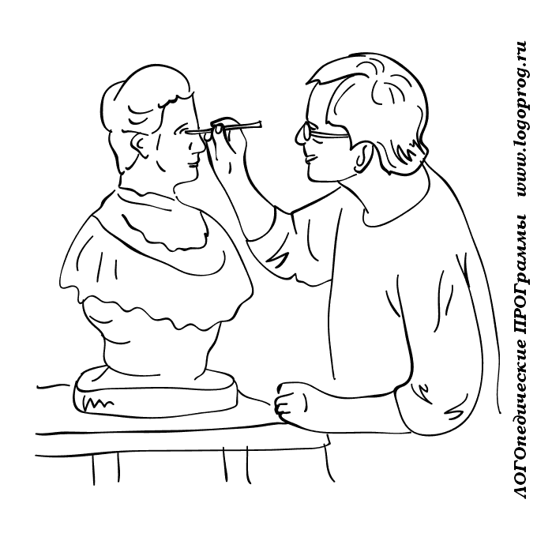
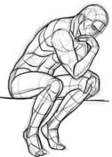

Patterns for coloring. London
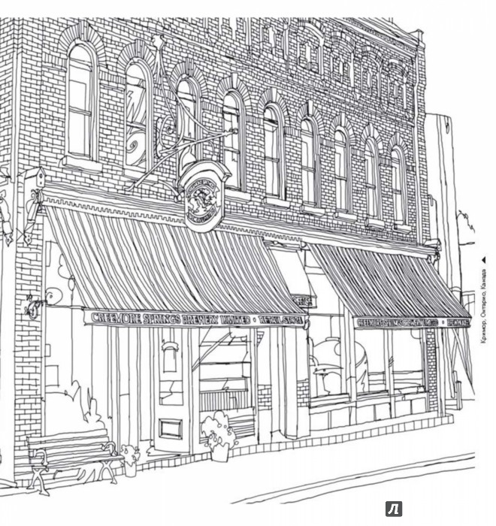

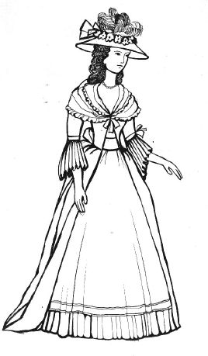

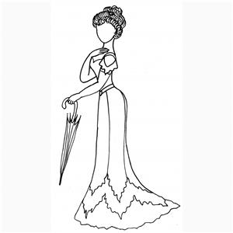

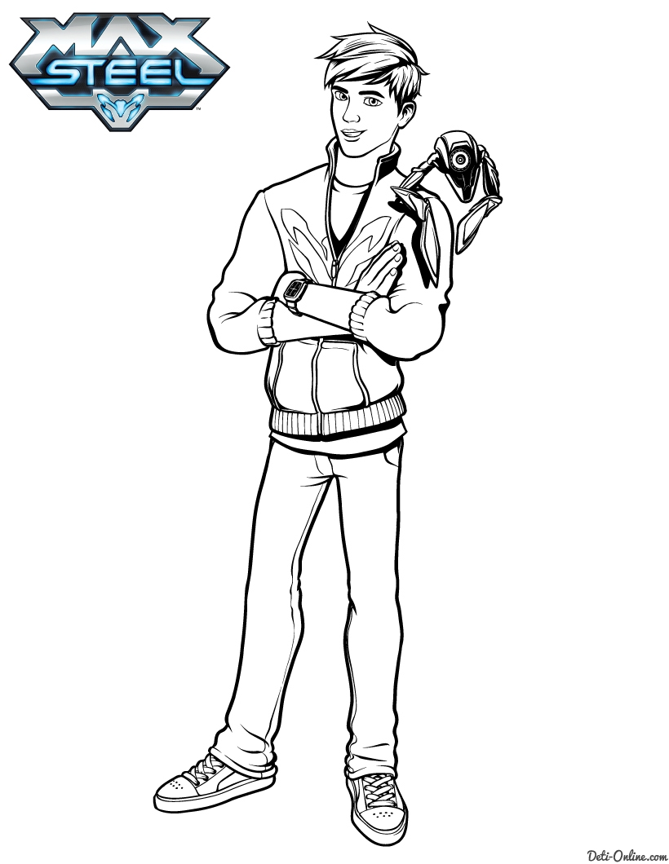

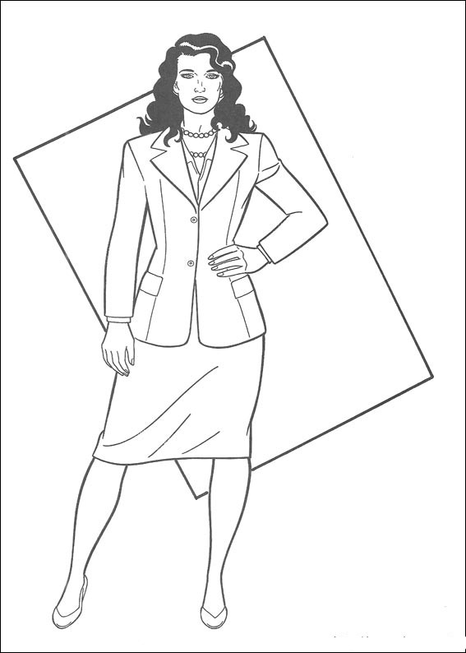

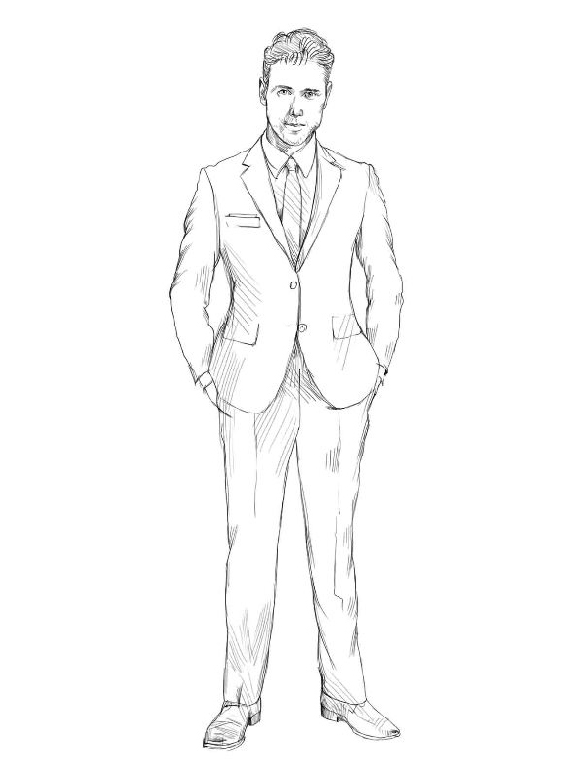

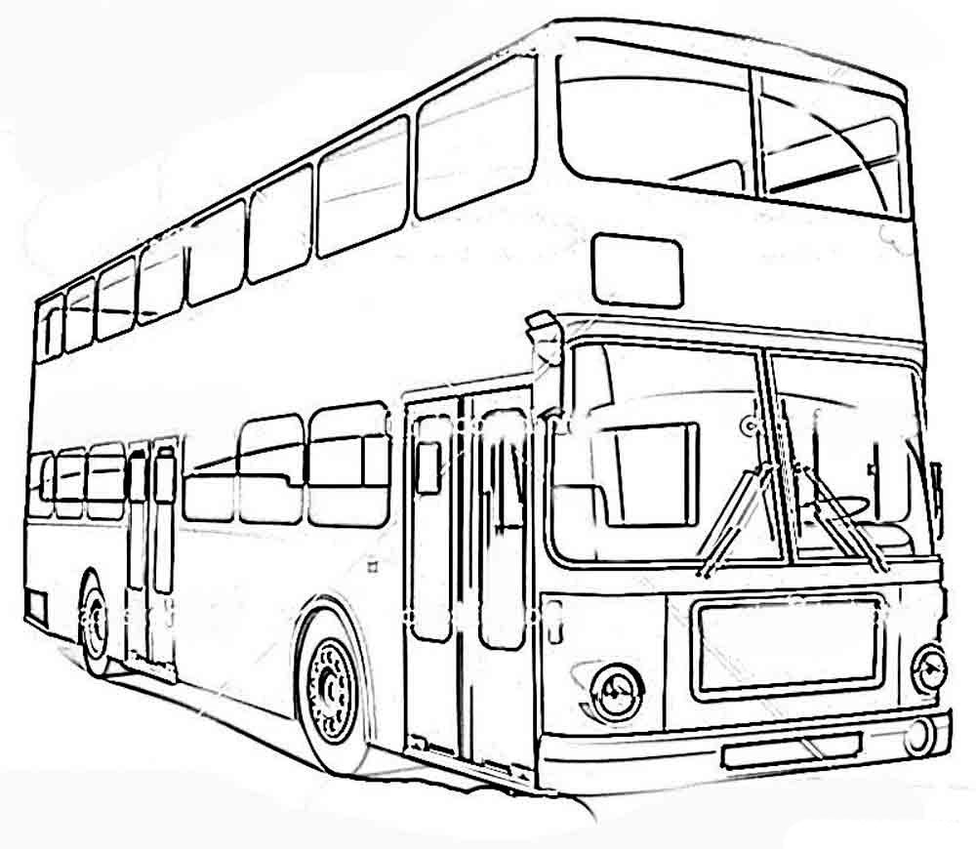
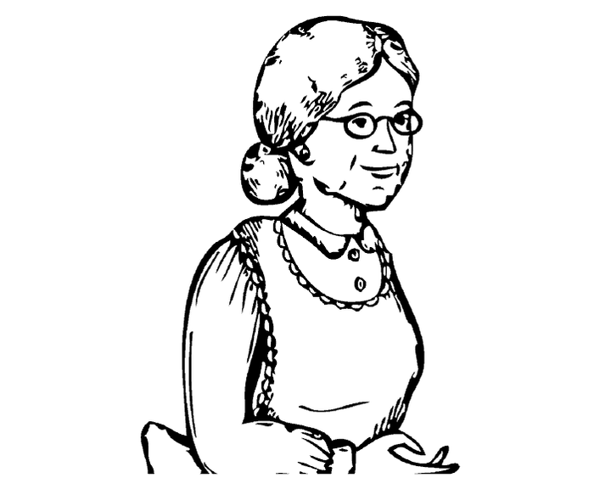

Patterns for coloring. Spiderman

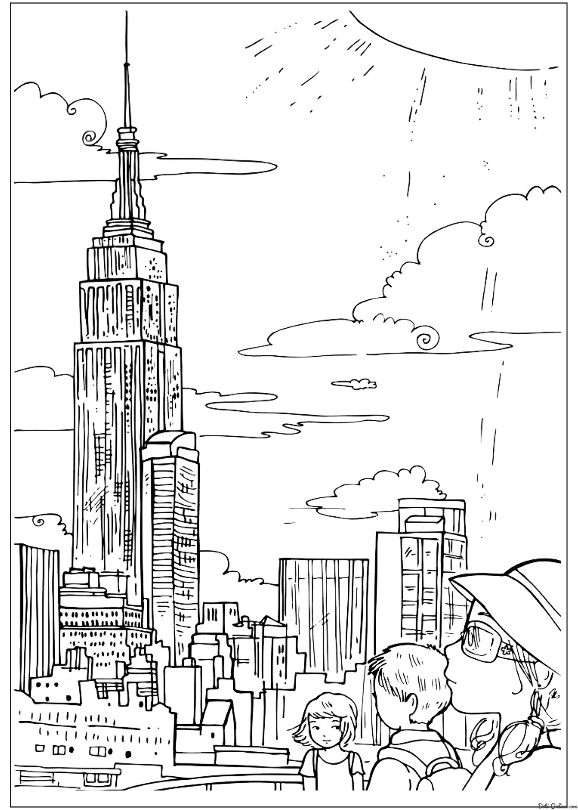

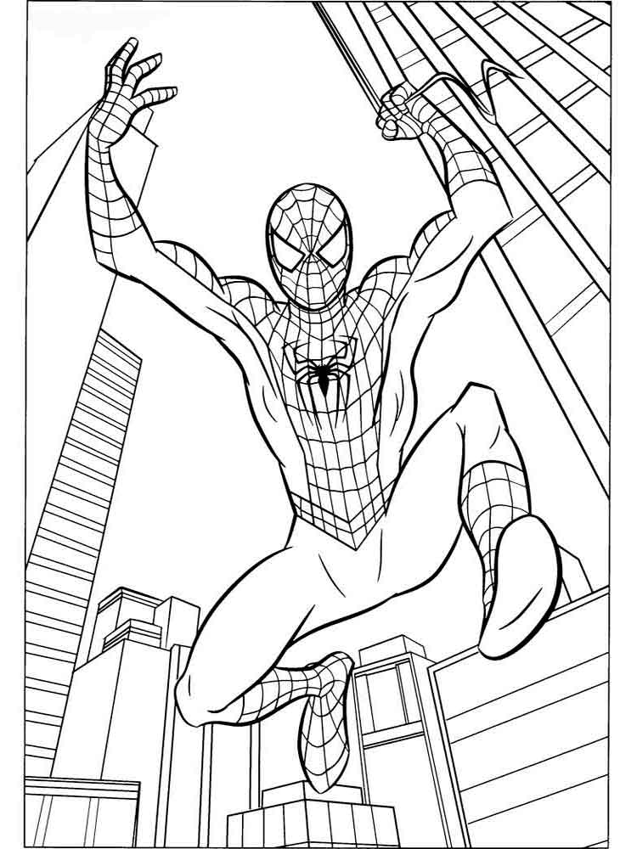

Patterns for coloring. York
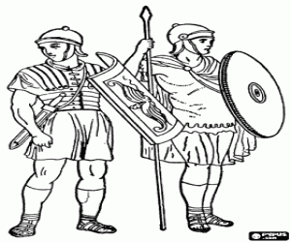

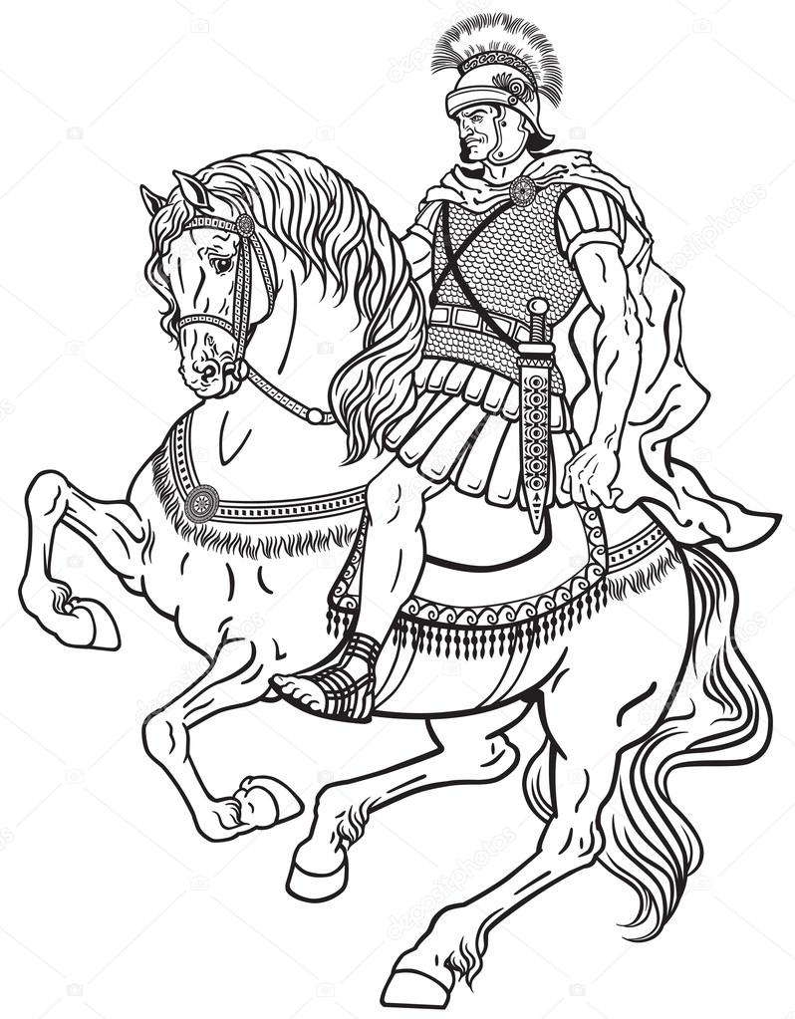

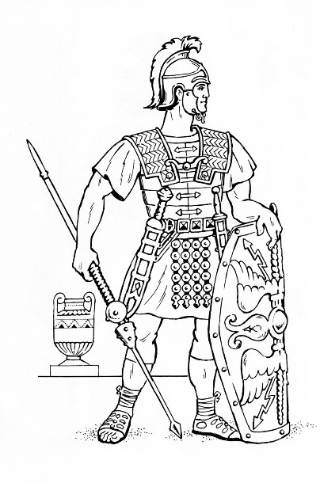

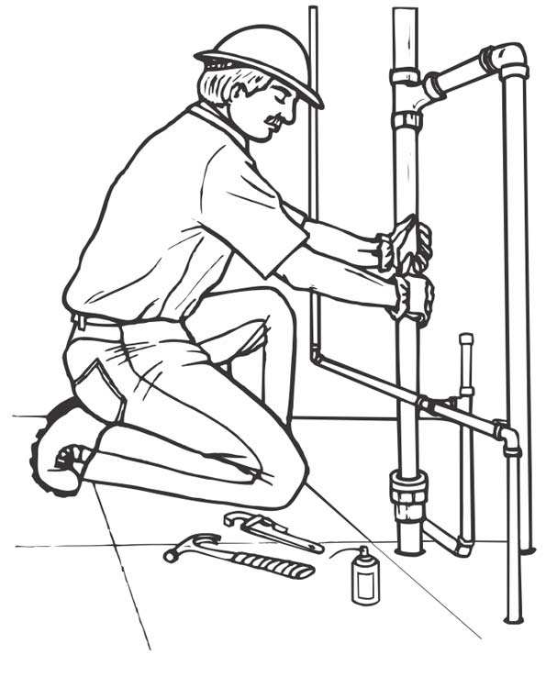

Photo. Spiderman
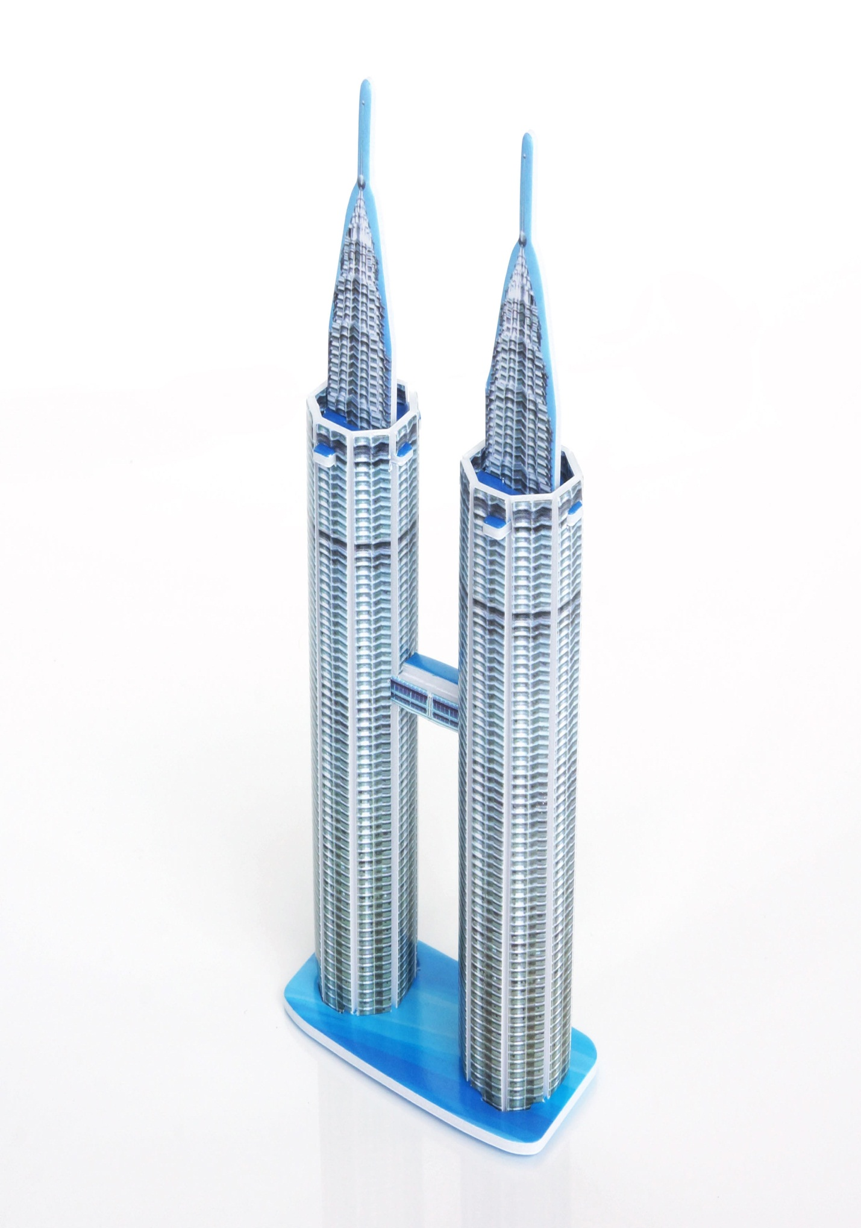

Photo.London

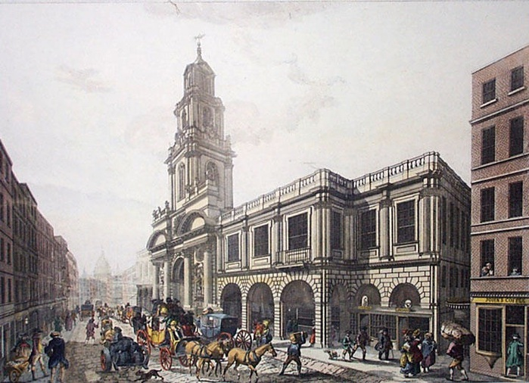
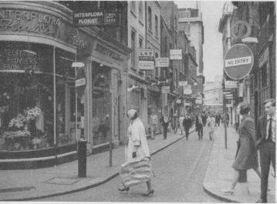

Photo. Opera
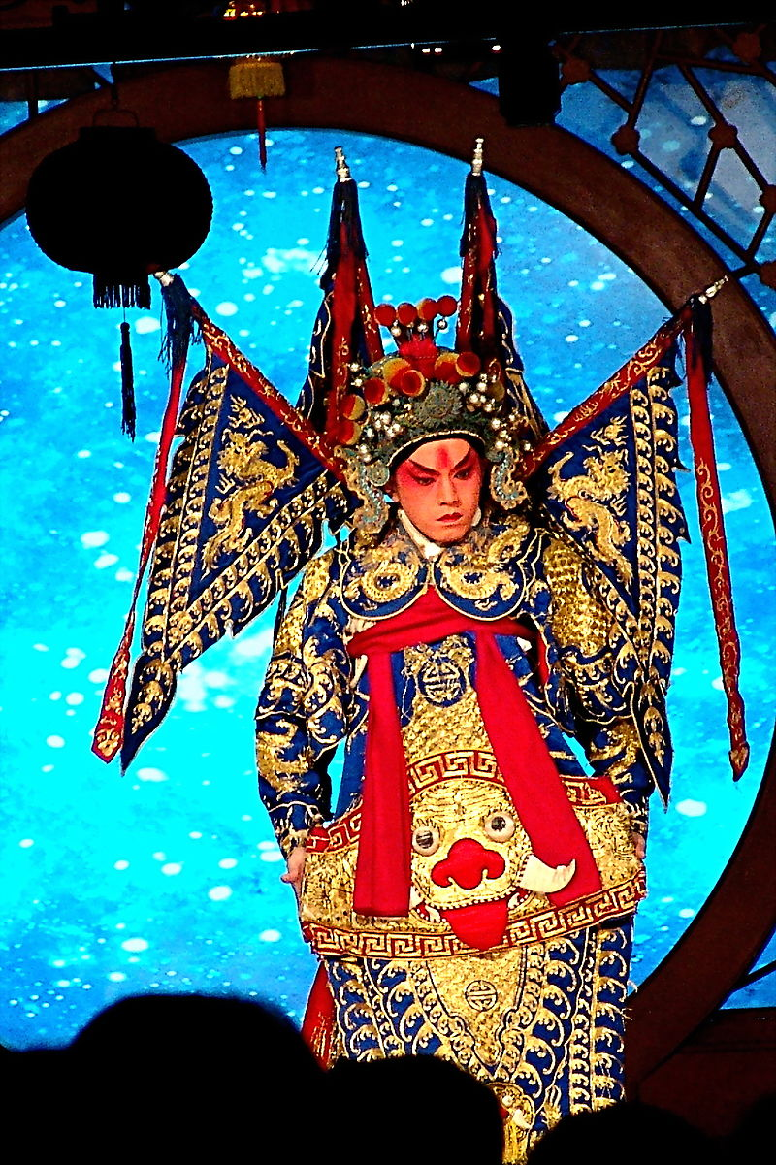

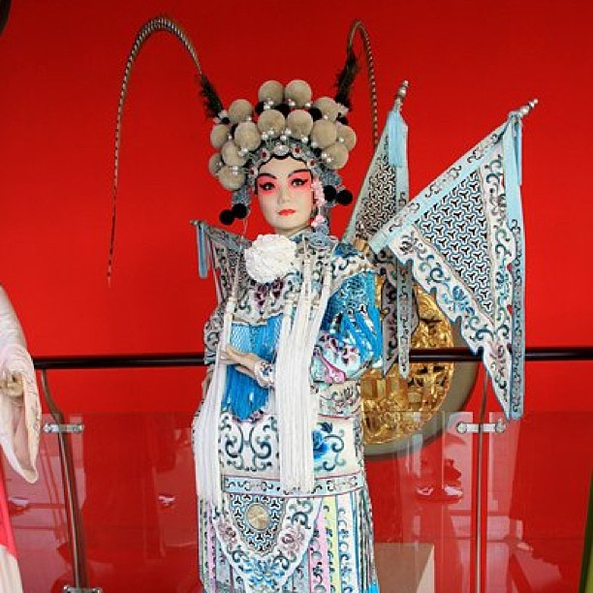

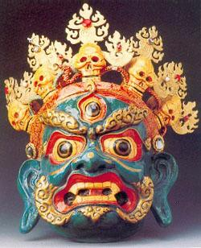

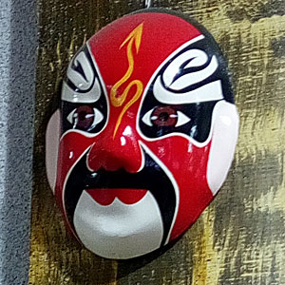

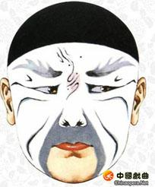

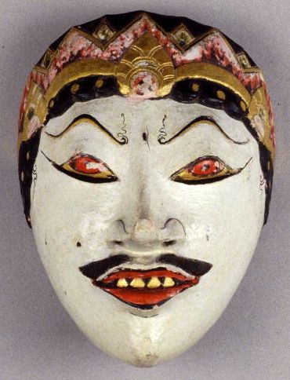

Photo. Sculptures
