Сценарий внеклассного мероприятия.
Организационная информация
Название | Игра – эстафета «You are the winner if you are healthy»
Тема | Здоровый образ жизни
 | для 1 курсов ССУЗов
Автор (ФИО, должность) | Девлитянс Олеся Владимировна, преподаватель английского языка
Образовательное учреждение | ГПОУ ЯО Ярославский градостроительный колледж

Цель: - мотивировать обучающихся применять на практике знания английского языка, актуализировать ведения здорового образа жизни;
Задачи:
- развивать знания о здоровом образе жизни, о занятиях спортом, путем введения в речь лексических единиц по теме;
- развивать память, внимание, языковую догадку и координацию движений;
- воспитывать сознательное побуждение к двигательной активности;

Организационный момент

Ведущий:
Hello students. I am very glad to see you. Today we have an extra class for our English. Is there anything more important than health? I don’t think so. I think it is very important to be fit and healthy and it is necessary to take care of your health. That's why we go in for sports, have useful meals, try to sleep 7 or 8 hours and get up early. We’ll take part in the competition. You can see that we have 2 teams. Please give names of your teams and your mottos and name your captains of the teams.
Let me introduce our jury.
Thank you. And now we know each other and I think it is high time to start your game.
Every victory in every location is 1 point. And every victory in the logical location is 1 point.
Location 1.
Each team is given 2 hoops. It is necessary to overcome the "swamp" with their help. There are 3 students in every team. At the signal, the first student of the team throws the hoop on the ground, all three players jump into it. You throw the second hoop to the distance from the first, so that you can jump into it. Then, you must reach out to the first hoop, without leaving the space of the second hoop. So, making jumps and throwing hoops, the group gets to the turning point. Here the team gives answers to riddles. The team returns back the same way.
Приложение №1
location 2.
Students of two teams are in a column one by one. The players of the teams are calculated in numerical order. The leader calls the number. For example: 1, then 5, and so on. Called players run to the established place, there run up to a rack, solve a rebus and come back. The team, whose player returned first, gets a point.
Every right rebus is 1 point.
You received instructions how to solve a rebus before the competition. I hope you've studied it. Be attentive!!!
Приложение №2
Приложение №3
Location 3.
The students are divided into teams. You stand behind each other. Each team has a balloon. The first student clamps the balloon between his knees and, like a kangaroo, jumps with it to the end of the distance. Three student of every team jump this way. Then your task is to complete the text, changing pictures to words. Return back in the same way. The winner is the team whose players will be the first. Every right picture is 1 point.
Приложение №4
Location 4
You are jumping in bags to the base, put the words in the logical order to make the proverbs. Each correctly composed proverb is 1 point.
Приложение №5
Location 5.

Students are divided into two teams into pairs. Pair task: to carry the egg between their foreheads to the base. You can support the egg with your hands only outside the starting line. You task is to guess what the sentence is about and complete it.
Приложение №6
Location 6

The bike will be replaced by a gymnastic stick. Stick need to ride just two students. They're cyclists. Each 2 students, holding between the legs a stick, will get to the base. Here one student will close his eyes with a scarf and come to the blackboard and draw a healthy man. The second student tries to describe the man. Every correct sentence is 1 point. As many sentences as many points. The fastest is the winner.

The jury calculates the scores and announces the results.

Приложение №1

- Ribbon, ball, beam and bars,
Ring next to them
I do not presume to list
A lot of shells.
Beauty and plastic
Gives us … (gymnastics)

- Assemble a team at school
And find a large field.
Punched corner —
Hammer head!
And at the gates of the fifth goal!
we love … (soccer)

- Here the team wins,
If the ball is not dropped.
He flies to feed aptly
Not the goal — over the net.
And the court, rather than the field
Athletes in … (volleyball)

- In this sport, players
All agile and high.
They love to play ball
And in the ring to throw it.
Ringing ball hits the floor,
So it’s … (basketball)

- In this sport you can kick a ball
Or you can also use your head
Try not to do a bad tackle
Or you will be shown a card that’s red
(football)

Приложение №2
Instruction:
Ребусы строятся по определённым правилам:
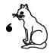
Разгадка: at. Запятая (или перевёрнутая запятая) справа (или слева) от картинки отбрасывает от слова одну букву с соответствующей стороны.
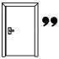
Разгадка: do. Если запятых несколько, отбрасывается соответствующее количество букв.
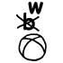
Разгадка: wall. Перечёркнутая (или исправленная на другую) буква над картинкой означает, что в слове нужно убрать (заменить) эту букву.
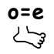
Разгадка: feet. Знак равенства между буквами, например, o=e, показывает, что в слове все буквы o нужно заменить на e.
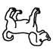
Разгадка: god. Перевёрнутая картинка означает, что буквы в слове нужно поставить в обратном порядке.
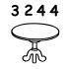
Разгадка: ball. Несколько цифр над картинкой означают порядок букв в слове. Если некоторые цифры отсутствуют или перечёркнуты, нужно убрать из слова соответствующие буквы.
Разгадка: tent. Если часть слова пишется одинаково с числительным, то в ребусе можно изобразить её числом.
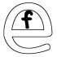
Разгадки: fine, phone. Взаимное расположение букв или картинок (друг над другом, внутри) указывает на то, что между ними нужно поставить соответствующий предлог.
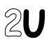
Разгадка: to you. Иногда в ребусах используются слова, которые произносятся так же, как и загаданное слово, а пишутся по-другому. Типичными примерами являются аббревиатуры букв и цифр: С - see, R - are, B4 - before, m8 - mate.
После того как вы прочитаете инструкцию, приступайте к разгадыванию ребусов. Запишите отгадку к ребусу на отдельный листочек, заранее приготовленный. Не забудьте пронумеровать ваши ответы.

Приложение №3
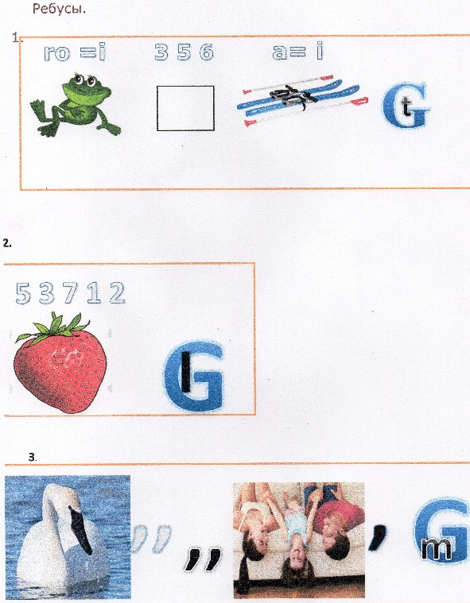
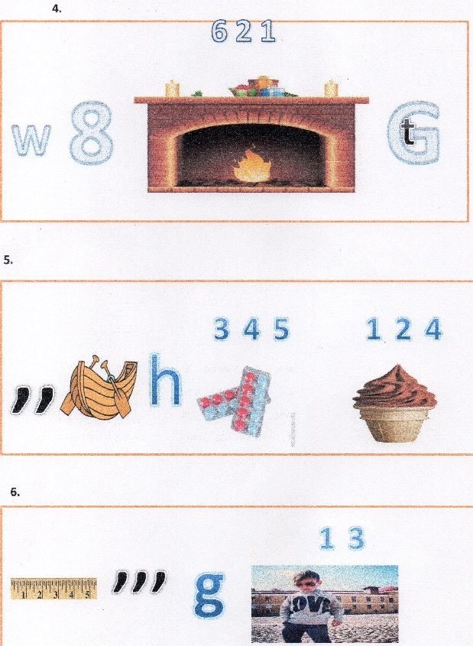
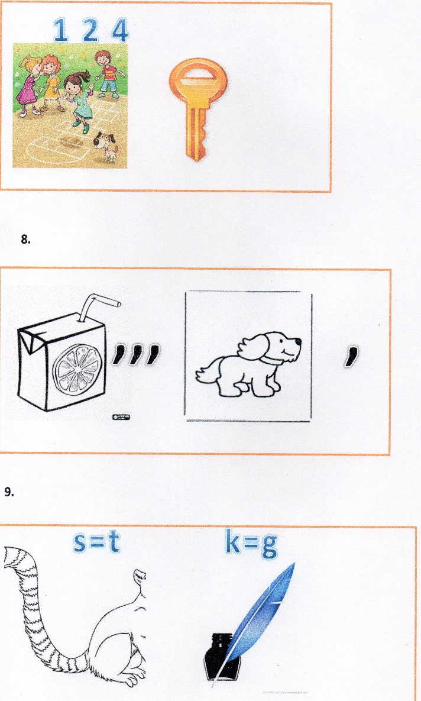
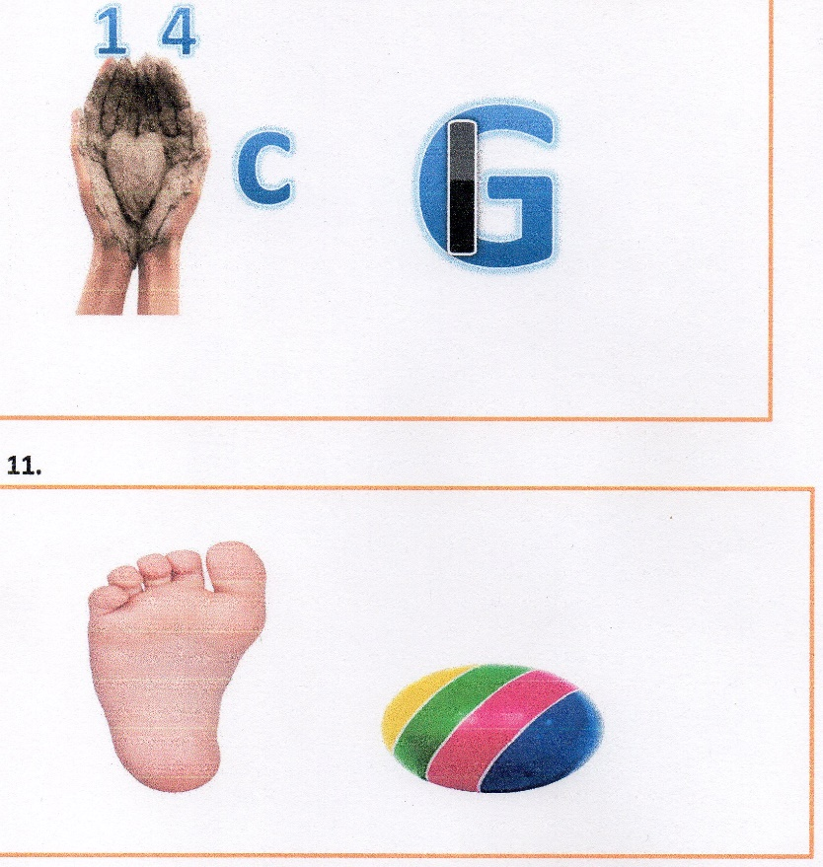
Приложение №4
Healthy Living Guide
The greatest 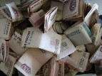 is . Some 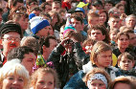 care about their , others don’t. can have good and bad habits. 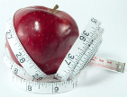 , eating wholemeal 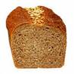, , eating low fat food is good for your . Physical inactivity, eating 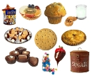, , 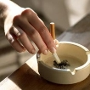 , are bad habits. It’s very important to care about your . Of course, 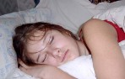 too much or too little, snacking and skipping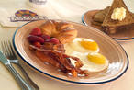 , make you unhealthy too. 7 or 8 hours, getting up early, eating , a healthy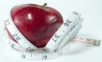 is really good for your . Many in GB and Russia think more about their . They attend fitness clubs, eat more and . Some of them count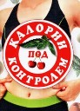 they eat every day. Some bad habits are really deadly. causes a 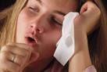. It makes your 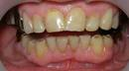 yellow,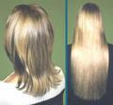 and clothes smell. causes a , disease and slow reactions. It also makes your speech unclear. As for , it causes 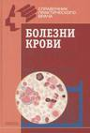, cancer and loss of memory. A lot of measures are taken against bad habits. You can be put into 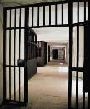 for , and sacked from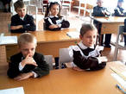 for and . is banned in , on the underground and in and 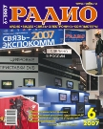 ads. Bad habits affect the whole family, around you, your knowledge and your social controls. If you want to be healthy some English proverbs саn help you: «Early to 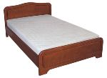 and early to rise, keeps a man healthy, wealthy and wise», «An a day keeps a 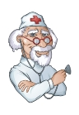 away », «Good friends are good for your », «A merry is a good medicine».

Приложение №5
Wealth, is, good, above, health. | Good health is above wealth
Healthy, fit, good, to, eat, food, keep. | Eat healthy food to kip fit
Be, take, a, shower, cool, to, healthy. | Take a cool shower to be healthy
Your, eat, wash, hands, before, you. | Wash your hands before you eat
Sweets, are, too, bad, many, teeth, for, your. | Too many sweets are bad for your  teeth
Apple, a, away, day, an, doctor, keeps, a. | An apple a day keeps a doctor away
Bird, the, worm, catches, the, early. | The early bird catches the worm.
Nothing, learn, by doing, we, to, ill, do. | By doing nothing we learn to do ill.

Приложение №6
For the first team.

Don’t put your elbows on the…( table)
Don’t stretch your feet out…( under) the table
Don t play with knives and forks, they are not toys
Try to make little… ( noise )
Don’t shovel food into your… ( mouth )
Don’t sip soup from a bowl.

For the second team.
Don t use a spoon for what
Can be eaten with a … (fork)
Cut the meat into small pieces
Which can be chewed very easy
Don t blow on the … ( food )
Don t talk with your mouth full
Don t forget to thank the … (hostess) and say « good-bye»
To the people sitting … (nearby).

Используемая литература и интернет - ресурсы:
- https://урок.рф/library/rebusi_po_teme_sport_103924.html
- http://razvitieiq.ru/raznoe/detskie-zagadki-pro-sport-s-otvetami-dlya-shkolnikov.html
- https://glashamoscow.ru/games-library/estafety/sportivnye-estafety/

